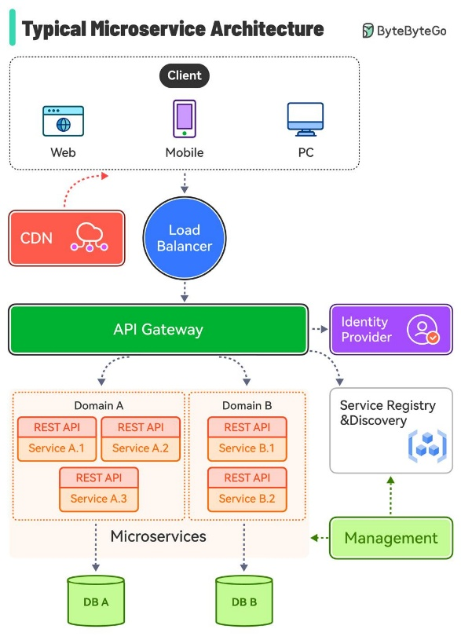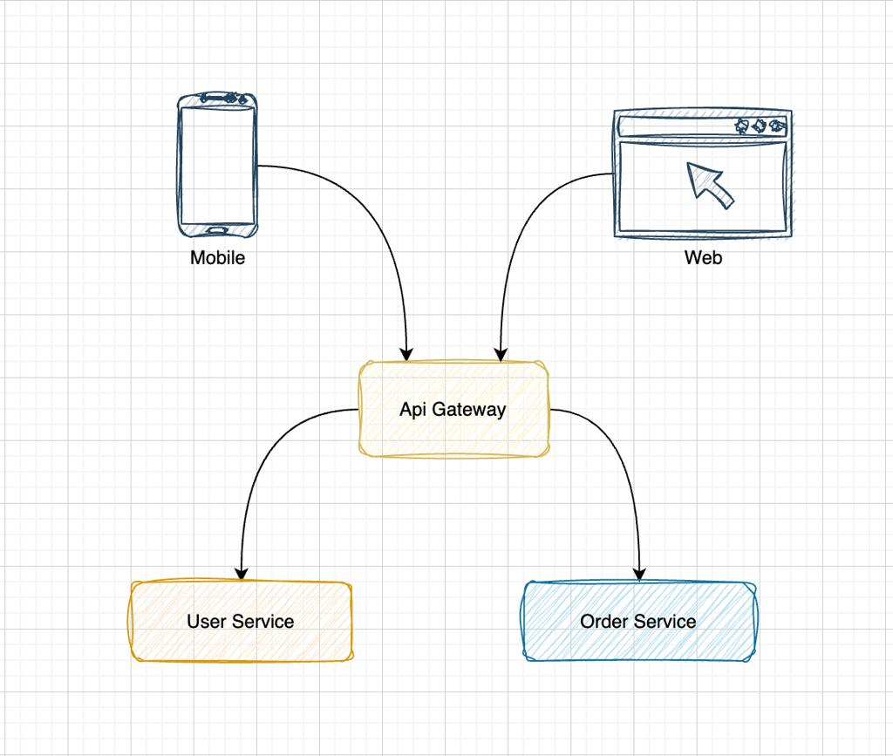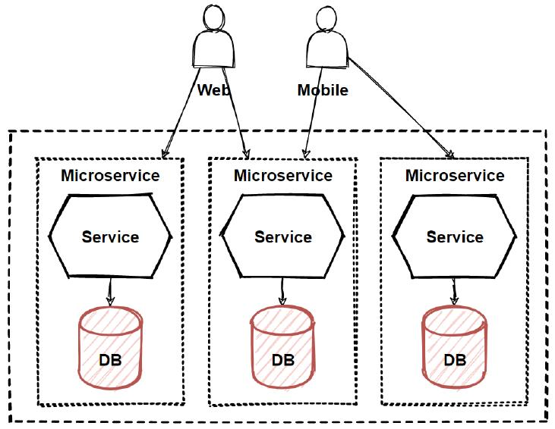
- UserService

user-service
└── src/main/java/com/example/userservice
├── UserServiceApplication.java
├── controller/UserController.java
├── model/User.java
└── service/UserService.java
User {
String id;
String username;
String password;
String role; // USER | ADMIN
}
- FoodService

food-service
└── src/main/java/com/example/foodservice
├── FoodServiceApplication.java
├── controller/FoodController.java
├── model/Food.java
└── service/FoodService.java
Food {
String id;
String name;
float price;
string type;
int availableQty;
}
- OrderService

order-service
└── src/main/java/com/example/orderservice
├── OrderServiceApplication.java
├── controller/OrderController.java
├── model/Order.java
├── service/OrderService.java
└── client/
├── UserClient.java
└── FoodClient.java

Order {
String id;
String userId;
List<String> foodIds;
Float total;
String status; // CREATED | PAID
}
- PaymentNotificationService

payment-service
└── src/main/java/com/example/paymentservice
├── PaymentServiceApplication.java
├── controller/PaymentController.java
├── model/Payment.java
├── service/PaymentService.java
└── client/
└── OrderClient.java
Payment {
String id;
String orderId;
String method; // COD | BANKING
String status; // SUCCESS
}

